**Configuring DHCP server within a LAN**

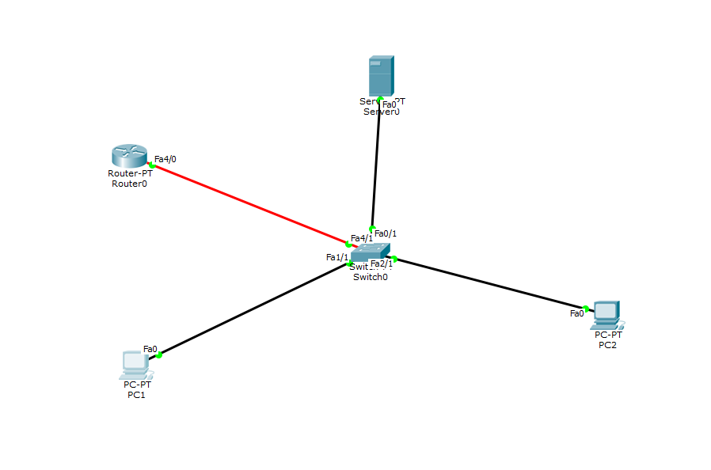

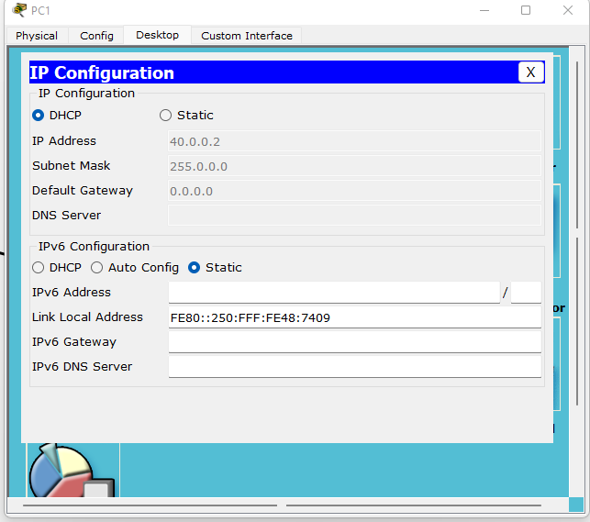

IP 40.0.0.2 assigned to PC1

IP 40.0.0.3 assigned to PC2

**How to config HTTP &DNS. Create a topology consisting of 2 End devices & 1 Server.**

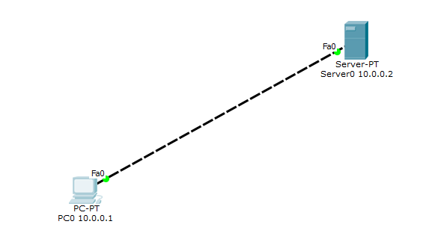

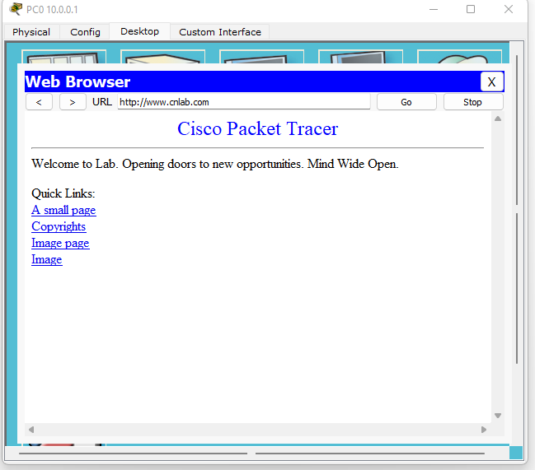

[www.cnlab.com](http://www.cnlab.com) accessed using DNS &HTTP